1. Difference between Test plan and Test Strategy .

Test strategy is a high level document which defines the approach for software testing. It is basically derived from the Business Requirement document. Test strategy is developed by project manager or business analyst. It is kind of static document which sets the standards for testing so not updated often.

Test plan is derived from SRS (*Software Requirement Specification*) which is prepared by test lead or manager. The main goal of test plan is to include all the details related to testing such as what to test, when to test, how to test and who will be the tester. Test plan is often not updated but if there is some new feature or change is introduced then it has to be updated accordingly.

**Components of the Test Strategy document**

* Scope and Objectives
* Business issues
* Roles and responsibilities
* Communication and status reporting
* Test deliverables
* Industry standards to follow
* Test automation and tools
* Testing measurements and metrices
* Risks and mitigation
* Defect reporting and tracking
* Change and configuration management
* Training plan

**Components of the Test Plan document**

* Test Plan id
* Introduction
* Test items
* Features to be tested
* Features not to be tested
* Test techniques
* Testing tasks
* Suspension criteria
* Features pass or fail criteria
* Test environment (Entry criteria, Exit criteria)
* Test deliverables
* Staff and training needs
* Responsibilities
* Schedule

1. Difference between Retesting and Regression
2. Do you more like work as TEST LEAD or Individual Contributor?

By definition, the basic responsibility of the test lead is to efficiently lead a team of testers to meet the product goals and hence the organization goals that are derived, are achieved. Off course, however straightforward the definition of the role is, it inherently translates into a whole series of responsibilities for the individual.

1. Be updated on the latest testing techniques, strategies, testing tools/ test frameworks and so on

2. Be aware of the current and upcoming projects in the organization

3. [Review and analyze the project requirements](http://youtu.be/Vz7TQ3eAQiU)

4. Plan and organize the [knowledge transfer](http://inderpsingh.blogspot.com/2010/02/what-is-best-way-to-get-knowledge.html) to the Software Test Engineers and self

5. Collect the queries related to the requirements and get them resolved by the business person (e.g. the client, business analyst, product manager or project manager) assigned to the project

6. Plan, organize and lead the testing kick-off meeting

7. Scope the required tests

8. Design the required [test strategy](http://youtu.be/vm5kGy6URjM) in line with the scope and organization standards

9. Create the software test plan, get it reviewed and approved/ signed-off by the relevant stakeholders

10. [Evaluate](http://inderpsingh.blogspot.com/2010/02/how-to-evaluate-automated-software-test.html) and identify the required test automation and test management tools

11. Estimate the test effort and team (size, skills, attitude and schedule)

12. Create the test schedule (tasks, dependencies and assigned team members)

13. Identify the training requirements of the Software Test Engineers

14. Identify any test metrics to be gathered

15. Communicate with the client or on site/ offshore team members, as required

16. Review the test cases and test data generated by the Software Test Engineers and get them to address the review comments

17. Track the new/ updated requirements in the project and modify testing artifacts accordingly

18. Determine, procure, control, maintain and optimize the test environment (hardware, software and network)

19. Get information on the latest releases/ builds from the development team/ the client

20. Create and maintain the required test automation framework(s)

21. Administer the project in the test management system

22. Administer the Application under test (e.g. add users for the tests), as required

23. Assign tasks to the Software Test Engineers based on the software test plan

24. Check the status of each assigned task daily and resolve any issues faced by the team members with their tasks

25. Ensure that each team member is optimally occupied with work (i.e. each Software Test Engineer should not be too overloaded or too idle)

26. Re-assign the testing tasks, as required

27. Track the assigned tasks with respect to the software test plan and the project schedule

1. Do you like to work in Structured or unstructured envn?

I do not prefer lot of process, what is more important is business want us to do

I am okayed in process, personally I would prefer the context of the process, business, what stakeholder wants, bugs, more important than process

I do not like to much process, I like light process, we should not prefer more on process, context is important than process

1. What kind of boss do you like?
   * Treat people at all levels with courtesy and respect
   * Clearly communicate responsibilities, boundaries, and expectations
   * Value the input and ideas of others and give them the credit
   * Remove roadblocks that prevent you from doing your job
   * Allow you the freedom to do your job with minimal supervision
   * Be available when you need them
   * Respect your privacy
2. Explain the steps or test cases for placing order and downstream steps for order completion. - Ecommerce flow:

1. Showing items in cart as you continue shopping on the top or right column  
2. Providing visual indicators for free shipping as items are added (i.e. "add one more product to receive free shipping")

2a. Ability to remove, save for later, change details like size

2b. Show the kind of payments they accept

2c. Show total price with the option to change shipping

3. Providing a "copy shipping address" for billing address forms  
4. Show product totals to user as they are added to shopping cart  
5. Clear call-to-action button for checkout

## What is Agile Methodology?

AGILE methodology is a practice that promotes **continuous iteration** of development and testing throughout the software development lifecycle of the project. Both development and testing activities are concurrent unlike the Waterfall model

### Scrum

SCRUM is an agile development method which concentrates specifically on how to manage tasks within a team-based development environment.

* Scrum Master
  + Master is responsible for setting up the team, sprint meeting and removes obstacles to progress
* Product owner
  + The Product Owner creates product backlog, prioritizes the backlog and is responsible for the delivery of the functionality at each iteration
* Scrum Team
  + Team manages its own work and organizes the work to complete the sprint or cycle

1. Explain about Agile flow in your last project.

8: 30 am stand up meeting with developer,

Sprint planning meeting,

Sprint execution,

2 weeks sprint  
Scrum is the most popular way of introducing Agility due to its simplicity and flexibility. Scrum has only three roles: Product Owner, Team, and [Scrum Master](http://scrummasterchecklist.org/pdf/ScrumMaster_Checklist_12_unbranded.pdf)

During the daily meetings, which are sometimes called "scrums," the scrum master asks the team members these three questions:

1. What did you do yesterday?  
2. What will you do today?  
3. Are there any impediments in your way? -- Backlog

The scrum master is responsible for:

1. Helping the team to reach consensus for what can be achieved during a specific period of time. (See [sprint](http://searchsoftwarequality.techtarget.com/definition/Scrum-sprint))  
2. Helping the team to reach consensus during the daily scrum.  
3. Helping the team to stay focused and follow the agreed-upon rules for daily scrums. (See [pigs and chickens](http://searchsoftwarequality.techtarget.com/definition/pigs-and-chickens))  
4. Removing obstacles that are impeding the team's progress.  
5. Protecting the team from outside distractions

*************************************************************************

1. How do you handle a situation where you are unable to complete testing and not meeting timelines?

* What is the risk involved,
* areas not have been tested,
* impact analysis,
* highlight the risk to the business to get the input,
* prioritize the risk
* what should and should not be tested

*************************************************************************************

1. Typical challenges encountered in web based testing?

* issue with navigation,
* links not working,
* 404 page not find,
* wrong exception,
* cross browser testing
* Cookies don't work properly (if applicable).
* CSS/HTML validation hasn't happened properly
* Concurrency issue

1. Web Service Testing - what is a web service, how do you test?

Web services are a collection of technological standards and protocols, including XML(Extensible Markup Language), the programming language by which applications communicate over the Internet.

Web services do not provide the user with a GUI.

A web service enables communication among various applications by using open

standards such as HTML, XML, WSDL, and SOAP. A web service takes the help of:

XML to tag the data

SOAP to transfer a message

WSDL to describe the availability of service.

UDDI is used for listing what services are available.

business service, you dun need to duplication, search is a webservice, you do not need to create your search, it's actually a provider, creating an order, closing a order, deleting an order, developed by shared services manner so that has been tested by different application, soap UI,directly send a requirement to webservice, the service should be coming as per the input

1. strength and weakness :

Strength : I always ask right question to BA, expected output, I wont hesitate to ask nything the BA, focussed getting thikngs done

weakness : i do not worklife balance, i really get along all the stakeholders very well, but probably a disadvantage

What is the difference between Severity and Priority?

There are two key things in defects of the [software testing](http://istqbexamcertification.com/what-is-a-software-testing/). They are:

1)     Severity

2)     Priority

What is the difference between Severity and Priority?

**1)  Severity**:

It is the extent to which the [defect](http://istqbexamcertification.com/what-is-defect-or-bugs-or-faults-in-software-testing/) can affect the software. In other words it defines the impact that a given defect has on the system.**For example:** If an application or web page crashes when a remote link is clicked, in this case clicking the remote link by an user is rare but the impact of  application crashing is severe. So the severity is high but priority is low.

Severity can be of following types:

* **Critical:**The defect that results in the termination of the complete system or one or more component of the system and causes extensive corruption of the data. The failed function is unusable and there is no acceptable alternative method to achieve the required results then the severity will be stated as critical.
* **Major:**The defect that results in the termination of the complete system or one or more component of the system and causes extensive corruption of the data. The failed function is unusable but there exists an acceptable alternative method to achieve the required results then the severity will be stated as major.
* **Moderate:**The defect that does not result in the termination, but causes the system to produce incorrect, incomplete or inconsistent results then the severity will be stated as moderate.
* **Minor:**The defect that does not result in the termination and does not damage the usability of the system and the desired results can be easily obtained by working around the defects then the severity is stated as minor.
* **Cosmetic:**The defect that is related to the enhancement of the system where the changes are related to the look and field of the application then the severity is stated as cosmetic.

**2)  Priority**:

Priority defines the order in which we should resolve a defect. Should   we fix it now, or can it wait? This priority status is set by the tester to the developer mentioning the time frame to fix the defect. If high priority is mentioned then the developer has to fix it at the earliest. The priority status is set based on the customer requirements.**For example:**If the company name is misspelled in the home page of the website, then the priority is high and severity is low to fix it.

Priority can be of following types:

* **Low:**The defect is an irritant which should be repaired, but repair can be deferred until after more serious defect have been fixed.
* **Medium:**The defect should be resolved in the normal course of development activities. It can wait until a new build or version is created.
* **High:**The defect must be resolved as soon as possible because the defect is affecting the application or the product severely. The system cannot be used until the  repair has been done.

**Few very important scenarios related to the severity and priority which are asked during the interview:**

**High Priority & High Severity**: An error which occurs on the basic functionality of the application and will not allow the user to use the system. (Eg. A site maintaining the student details, on saving record if it, doesn’t allow to save the record then this is high priority and high severity bug.)

**High Priority & Low Severity:** The spelling mistakes that happens on the cover page or heading or title of an application.

**High Severity & Low Priority:** An error which occurs on the functionality of the application (for which there is no workaround) and will not allow the user to use the system but on click of link which is rarely used by the end user.

**Low Priority and Low Severity:** Any cosmetic or spelling issues which is within a paragraph or in the report (Not on cover page, heading, title).

[**?**](http://www.yieldselect.com/index/ref/1/)

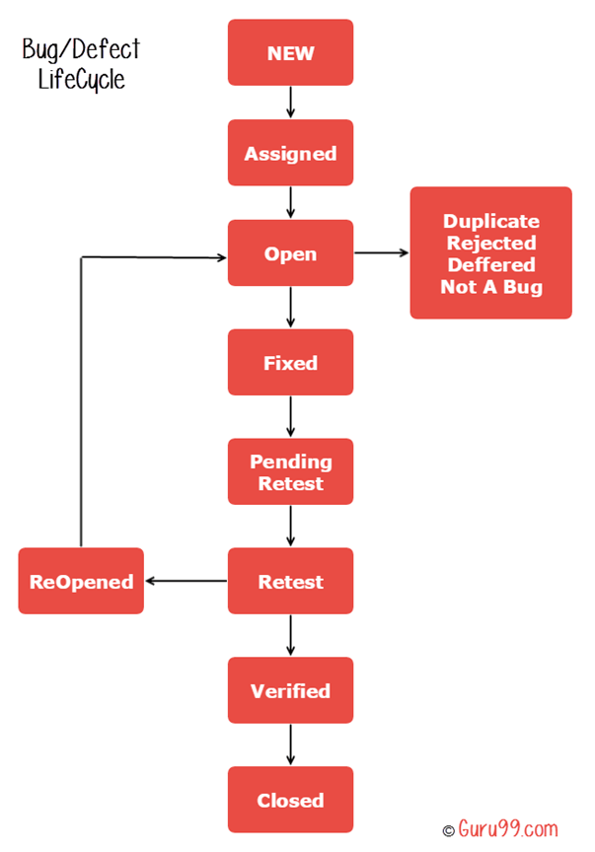

# Test Scenarios Login Page

1. Verify that the login screen is having option to enter username and password with submit button and option of forgot password
2. Verify that user is able to login with valid username and password
3. Verify that user is not able to login with invalid username and password
4. Verify that validation message gets displayed in case user leaves username or password field as blank
5. Verify that validation message is displayed in case user exceeds the character limit of the user name and password fields
6. Verify that there is reset button to clear the field's text
7. Verify if there is checkbox with label "remember password" in the login page
8. Verify that the password is in encrypted form when entered
9. Verify that there is limit on the total number of unsuccessful attempts
10. For security point of view, in case of in correct credentials user is displayed the message like "incorrect username or password" instead of exact message pointing at the field that is incorrect. As message like "incorrect username" will aid hacker in bruteforcing the fields one by one
11. Verify the timeout of the login session
12. Verify if the password can be copy-pasted or not
13. Verify that once logged in, clicking back button doesn't logout user
14. Verify if SQL Injection attacks works on login page
15. Verify if XSS vulnerability work on login page

<https://careercup.com/page?pid=testing-quality-assurance-interview-questions>

**What is Incognito mode:**

To understand why you'd want to use private browsing (known as "incognito mode" on the popular browser Chrome), it's best to first understand [how incognito mode works](http://www.howtogeek.com/117776/htg-explains-how-private-browsing-works-and-why-it-doesnt-offer-complete-privacy/). When you open a browser window in private or incognito mode, the browser stops storing all the various stuff it usually stores about sites as you putter around the information superhighway. Typically, this stored stuff includes things like the site's URL, text you may have typed into the site's forms, and [cookies from websites](http://www.bbc.com/privacy/cookies/about) (that enable the browser remember your language preference or save your digital shopping cart, for instance). And, very obviously, when you are not in private browsing mode, the browser logs sites you've visited into your "history" log, along with the date and time of the visit.

Incognito mode doesn't offer complete privacy. Your internet service provider still knows where you've browsed, so while incognito mode might hide your searches from your mom, it can't really help you hide from the police and their subpoenas. If someone like your employer is monitoring all of its network's activity from a central location, they'll know where you (or your computer) has navigated, too.

But for personal day-to-day purposes, the incognito mode is really valuable

[**Write test cases to test a browser App**](https://careercup.com/question?id=5728041465544704)

Refresh/Reload, Save As, Save As Target etc  
Opening of page (Server, Cached)  
CSS heavy websites, Flash heavy, image heavy, js heavy, HTML5 heavy, embedded script, SQL based query, Client server types, Request/Response heavy website,Media player sites etc  
Bookmarks and bookmarks bar support  
Various extension support  
Data backup functionnality  
Cookie support  
Multiple login/account handling support  
Browsing History  
Cache  
Incognito mode support  
Language support  
Privacy settings  
Third party cookie handling  
Extension support  
External embedded services support  
Network support (LAN/WAN/Wifi/CableNet etc)  
Text/Font/color/RichText, Flash support  
Encoding support

[**Write test cases for refrigerator?**](https://careercup.com/question?id=5673160297938944)

**Functional test cases** for refrigerator:  
1. power on and check the compressor is running and cooling happens.  
2. check for the compressor cutoff time.  
3. check the freezer section. test with deep frozen items like ice-creams, ice-cubes etc.  
4. check the food/fruit/veggie section with different food items.  
5. check the lock of the refrigerator.  
6. check for cooling leaks from the door or any sides of refrigerator.  
7. power on the refrigerator and open the doors of refrigerator. check the compressor is running continously or not.  
8. check by adjusting the cooling temperature.  
9. check cooling of refrigerator in beyond room temperature conditions.  
10. check the defrost mode.  
  
  
**Non-Functiona**l test cases for refrigerator   
  
1. check with different power voltages.  
2. load the food items upto and beyond the capacity.  
3. switch off the power and check how long cooling withstand.  
4. check what happens if we place the refrigerator upside down and run it.  
5. check for water resistance of the door.

**Usability**:  
check size/dimensions of the fridge if they are as per the specs  
check the color as per the specs  
check the texture and check the durability of the color by washing/cleaning the surface multiple times  
check interior color, material, durability  
check the hinges of the doors (fridge and deep freezer) by opening and closing the doors multiple times continuously  
check if the interior can be cleaned easily  
verify the sizes of all the slots if they are as per the specs  
check for the sustenance of the shelves with the allowed weights and disallowed weights  
check the overall weight of the fridge if it is as per the specs  
  
**Installation testing:**Connect to the power it is intended to take and verify  
check the length of the wire and the size of the plug pin if it conforms to the specs which include the type of the plug pin for the particular country  
Material of the wire and the plug pin if they are durable.   
Colour of the above

[**What all Smoke test cases should be performed, if a defect fix is given for a module C. Data will come to module C if its integrated with other Modules say A , B.**](https://careercup.com/question?id=4991768313462784)

1. Check whether module C is integrated with modules A & B or not ?  
2. Check data is coming to module C from modules A & B if it is integrated.  
2. Do basic functionality on module C.

[**Write 4 testcases for the usecase "Customers buy a book with the credit card payment option."**](https://careercup.com/question?id=5197804481806336)

1)Validate whether book is in stock to buy   
2)Provide incorrect card details , and verify payment failure   
3)Provide correct card details and verify payment success   
4)If the book is out of stock , it should not allow to place the order .

[**Write a test plan for the first time launch of a website that will sell digital books.**](https://careercup.com/question?id=5747515668299776)

1. Overview of the Project  
2. Scope of the project   
3. What level of testing will be done and what will be covered  
4. Entry and Exit criteria for each level of testing.   
5. Environment requirement and Details.   
6. Test data requirements.   
7. System Testing schedule and Interfacing application schedules  
8. Risk Management  
10. Cross project dependency   
11. Project Assumptions.   
12. Signoff details

**Boundary value analysis and Equivalence partitioning :**

Boundary value analysis and equivalence partitioning both are test case design strategies in black box testing.

**Equivalence Partitioning:**

**Test cases for input box accepting numbers between 1 and 1000 using Equivalence Partitioning:**  
**1)** One input data class with all valid inputs. Pick a single value from range 1 to 1000 as a valid test case. If you select other values between 1 and 1000 the result is going to be same. So one test case for valid input data should be sufficient.

**2)** Input data class with all values below the lower limit. I.e. any value below 1, as an invalid input data test case.

**3)** Input data with any value greater than 1000 to represent third invalid input class.

**[(Any value between 1-1000), (lower limit-1), (Highest limit+1)]**

**e.g.[237, 0, 1001]**

So **using equivalence partitioning you have categorized all possible test cases into three classes**. Test cases with other values from any class should give you the same result.

**Boundary value analysis:**

**Test cases for input box accepting numbers between 1 and 1000 using Boundary value analysis:**  
1) Test cases with test data exactly as the input boundaries of input domain i.e. values 1 and 1000 in our case.

2) Test data with values just below the extreme edges of input domains i.e. values 0 and 999.

3) Test data with values just above the extreme edges of input domain i.e. values 2 and 1001.

e.g.**[(1,1000),(0,999),(2,1001)]**

Boundary value analysis is often called as a part of stress and negative testing.

How to calculate Statement, Branch/Decision and Path Coverage for ISTQB Exam purpose

**How to calculate Statement Coverage, Branch Coverage and Path Coverage?**

Draw the flow in the following way-

* Nodes represent entries, exits, decisions and each statement of code.
* Edges represent non-branching and branching links between nodes.

**Example:**

Read P  
Read Q  
IF P+Q > 100 THEN  
Print “Large”  
ENDIF  
If P > 50 THEN  
Print “P Large”  
ENDIF

Calculate statement coverage, branch coverage and path coverage.

**Solution:**  
The flow chart is-

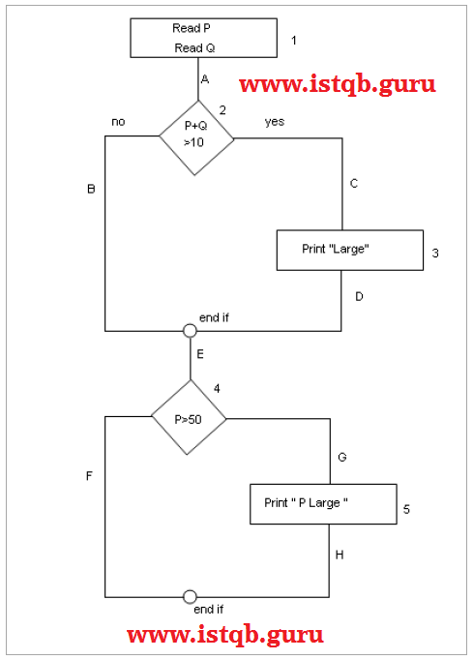

**Statement Coverage (SC):**

To calculate Statement Coverage, find out the **shortest number of paths following which all the nodes will be covered**. Here by traversing through path 1A-2C-3D-E-4G-5H all the nodes are covered. So by traveling through only one path all the nodes 12345 are covered, so the **Statement coverage in this case is 1**.

**Branch Coverage (BC) or Decision coverage:**

To calculate Branch Coverage, **find out the minimum number of paths which will ensure covering of all the edges**. In this case there is no single path which will ensure coverage of all the edges at one go. By following paths 1A-2C-3D-E-4G-5H, maximum numbers of edges (A, C, D, E, G and H) are covered but edges B and F are left. To covers these edges we can follow 1A-2B-E-4F. By the combining the above two paths we can ensure of traveling through all the paths. Hence Branch Coverage is 2. The aim is to cover all possible true/false decisions.

**Path Coverage (PC):**

**Path Coverage ensures covering of all the paths from start to end**. All possible paths are-

1A-2B-E-4F  
1A-2B-E-4G-5H  
1A-2C-3D-E-4G-5H  
1A-2C-3D-E-4F

So path coverage is 4.

Thus for the above example SC=1, BC=2 and PC=4.

<https://www.guru99.com/learn-statement-coverage.html>

<https://www.tutorialspoint.com/software_testing_dictionary/decision_coverage_testing.htm>

**Decision coverage:**   
Decision coverage or Branch coverage is a testing method, which aims to ensure that each one of the possible branch from each decision point is executed at least once.

**Example :**

Read A Read B IF A+B >10 THEN Print"A+B is Large" ENDIF If A >5 THEN Print"A Large"ENDIF  
  
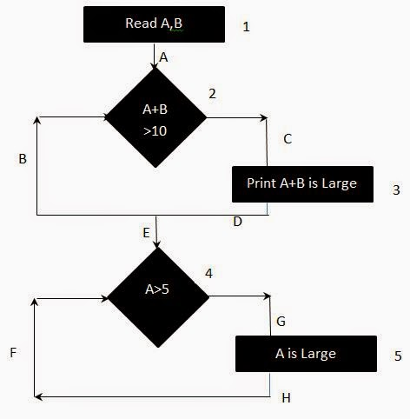  
**Calculate Branch Coverage:**  
find out the minimum number of paths which will ensure that all the edges are covered. In this case there is no single path which will ensure coverage of all the edges at once. The aim is to cover all possible true/false decisions.  
(1) 1A-2C-3D-E-4G-5H  
(2) 1A-2B-E-4F Hence Decision or **Branch Coverage is 2.**  
 **Statement Coverage:**To calculate Statement Coverage, find out the shortest number of paths following which all the ***nodes will be covered***.   
Here by traversing through path ***1A-2C-3D-E-4G-5H*** all the nodes are covered. So by traveling through only one path all the nodes are covered.  
So the**Statement coverage is 1**

[**Need to write Boundary Value Analysis cases - Scenario is , A book seller takes order of minimum of 5 books and if any person is ordering more then 100 books he will get discount of 20%.   
What will be the boundary values for the above case.**](https://careercup.com/question?id=5102617566904320)

Ans: [5,100]

[4,99]

[6,101]

[5,100] interval  
We can have 2 boundaries or 3 boundaries.  
Lower boundary : 4,5 or 6   
Upper boundary: 100,101 or 99

[**Write test cases for a software which accepts inputs as dd/mm/yyyy and gives output as 4 days after the input.   
  
ex-input-07/01/2011..out put should be 11/01/2011.**](https://careercup.com/question?id=5689203899760640)

Bounday Values should be   
  
Year and month change   
A. 27/12/2012 it should return 31/12/2012   
B. 28/12/2012 it should return 1/1/2013 

Leap year check   
1. 25/02/2012 it should return 29/02/2012   
2. 26/02/2012 it should return 01/03/2012   
3. 25/02/2013 it should return 01/03/2013   
4. 24/02/2013 it should return 28/02/2013   
No need to check 31st as we already tested it on scenario A,B   
Check 30 days change also.

[**How will you test Amazon.com website?**](https://careercup.com/question?id=5165888718241792)

1> can we access webpage on browser?   
2> can we open web site on different devices with different browsers?   
3> All the search boxes, dropboxes, menubars, buttons are on the place.   
4> login, logout, registation component test.   
  
5> static + dynamic content tests?   
6> find the capability of each component.   
7> test each component one by one   
8> system tests   
9> security tests for the website   
10> performance test   
11> memory test for the website   
if everything passes send it to dog fooding to partners and internal users

[**Debug Scenarios for :   
1. Double Clicking the MP3 File and Nothing happens   
2. Double clicking the Player and then playing the file and nothing is heard**](https://careercup.com/question?id=6251163301183488)

**1st Scenario:**  
1) Check if any mp3 supportive player is available in system.   
2) For different operating systems , check file permission levels.   
3) Check if file is corrupted.   
4) Check scenarios with respect to file size.   
5) Check whether user is able to play file using right clicking and selecting some player.   
  
**Scenario 2:**   
1) Check for player sound, system sound, sound driver in system.   
2) Check if file have some sound or it has only video.   
3) Check if file is supported by player and other cases of scenario 1.   
4) File duration related test cases.